# CS 255 System Design Document Template

This template lays out all the different sections that you need to complete for Project Two. Each section has guidance to prompt your thinking. You will need to continually reference the interview transcript as you work to make sure that you are addressing your client’s needs. There is no required length for the final document. Instead the goal is to complete each section based on what your client’s needs are. Remove this note when you are finished, and replace all bracketed text with the relevant information.

## UML Diagrams

### UML Use Case Diagram

*[In Module Six, you were asked to complete a use case diagram based on your system design. If you would like to make any adjustments to your diagram, please do so. Please insert your use case diagram here. Check to make sure that you included appropriate components and symbols and that your design meets the client’s needs.]*

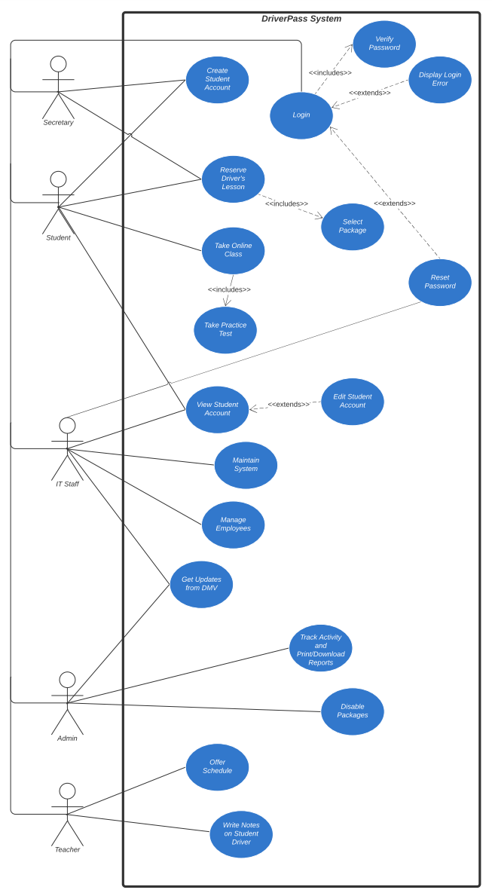

### UML Activity Diagrams

*[You were asked to choose* ***two*** *use cases and create* ***two*** *activity diagrams, one for each use case. Please insert* ***both*** *of your activity diagrams here. Check to make sure that you included appropriate components and symbols and that your design meets the client’s needs.]*

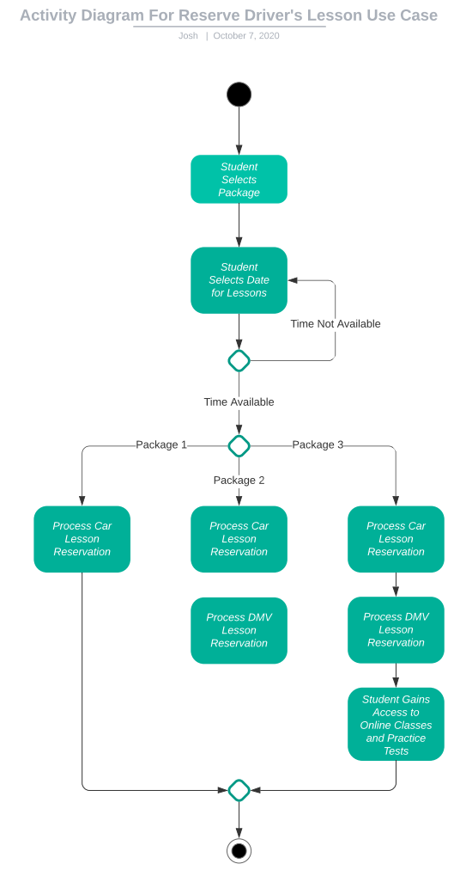

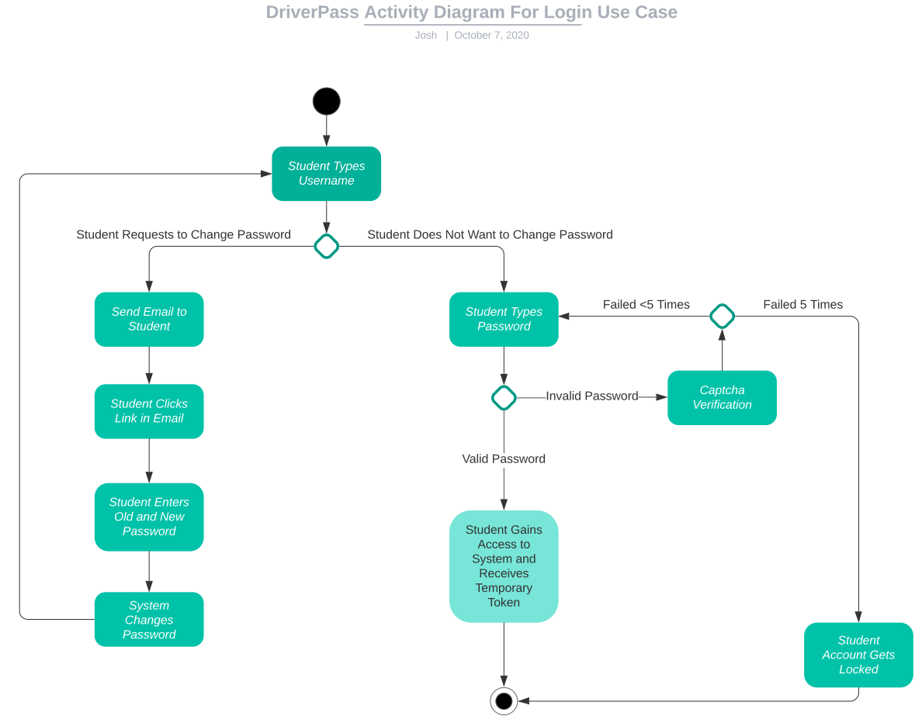

### UML Sequence Diagram

*[You were asked to create a sequence diagram based on* ***one*** *of the use cases you chose. Please insert your sequence diagram here. Check to make sure that you included appropriate components and symbols and that your design meets the client’s needs.]*

Sequence Diagram for Reserve Driver’s Lesson:

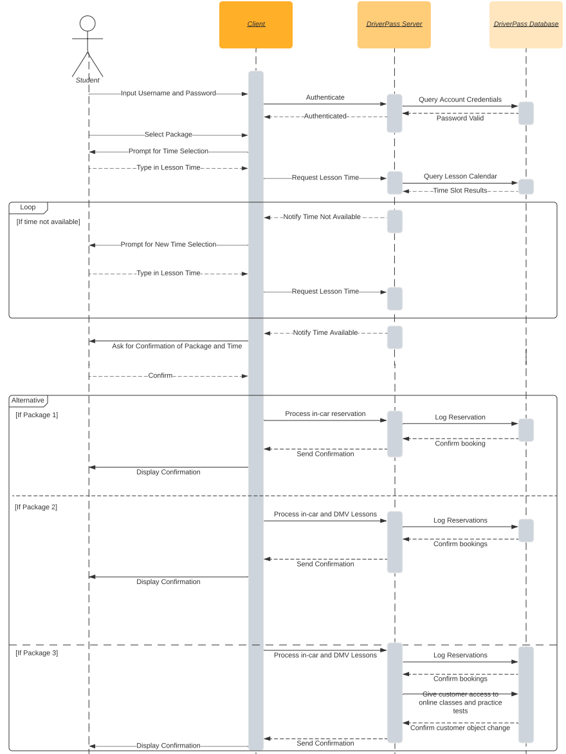

### UML Class Diagram

*[You were asked to create a class diagram based on the different classes and attributes needed for your system design. You are* ***not*** *required to include methods, but you may if you wish. Please insert your class diagram here. Check to make sure that you included appropriate components and symbols and that your design meets the client’s requirements.]*

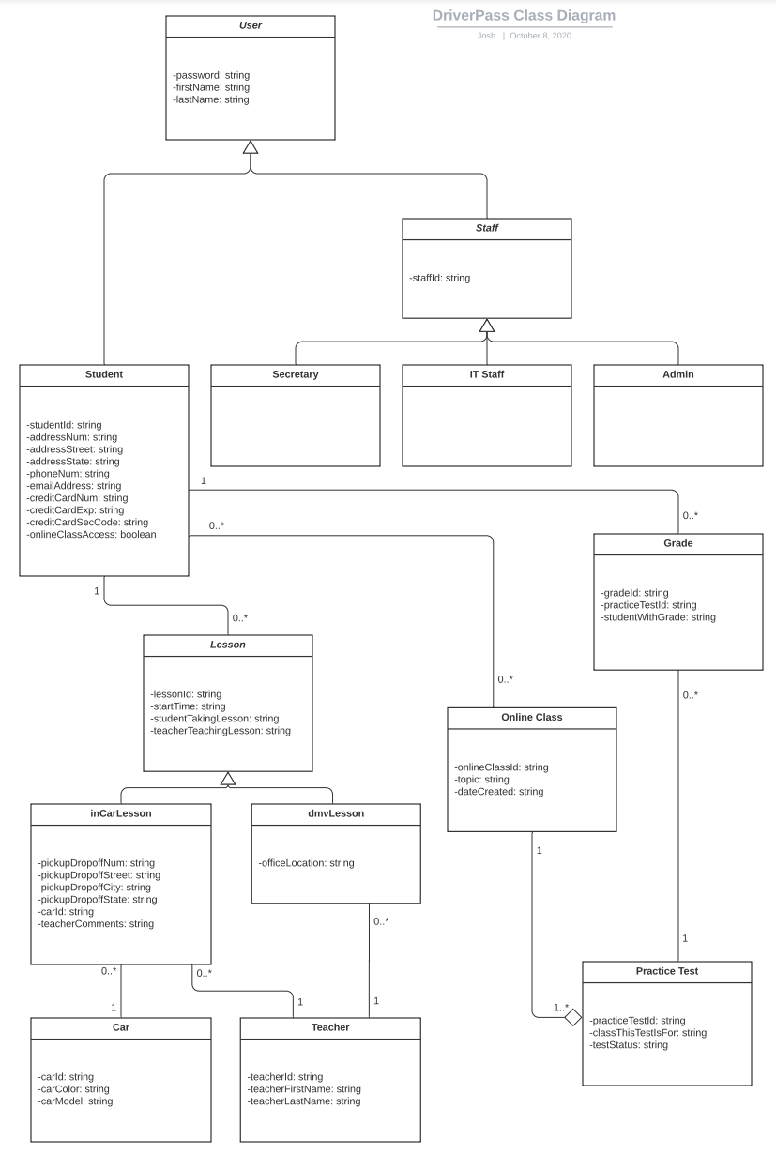

## Technical Requirements

*[Based on the diagrams you have created, describe the technical requirements of your system. These requirements should address the required hardware, software, tools, and infrastructure necessary for your system design.]*

Hardware:

* Server with modern processor, at least 16GB of DDR4 or better RAM
* Enough storage for database, application, and miscellaneous items such as driver photos. The storage should be an SSD or a fast HDD at the very least
* Clients should be modern PCs, laptops, and mobile devices such as iPad, iPhone or Samsung Galaxy
* The server’s LAN shall require a firewall appliance

Software:

* The server shall run a credible commercial version of Linux for its operating system
* Clients shall run popular web browsers on traditional desktop operating systems or mobile operating systems such as iOS or Android
* The server and database computers shall have firewall and antivirus software

Tools:

* The system shall require a set of backend languages such as: Java, Python, mySQL
* The system shall require a set of frontend languages such as: HTML, CSS, JavaScript
* The system shall require a set of technologies to aid development and maintenance of the backend such as: backend frameworks, framework servlets, HTTP server, API for java-database connection

Infrastructure:

* The system shall be hosted offsite in the cloud. The choices are between AWS, Azure, and GCP
* The server will require high speed upload and download speeds, preferably a fiber optic connection